Important Notice of Change
From Timber Lane Utility District

The Timber Lane Utility District has recently changed its customer service and operations company to M. Marlon Ivy & Associates, Inc. (MMIA) as part of its ongoing commitment to high quality customer service.

What this means for you:

- Beginning August 1, 2022, all billing, collection, and service inquiries should be directed to MMIA at 281-651-1618.
- Payment of your July 2022 water bill should be mailed to
Timber Lane UD, P.O. Box 9, Spring, Texas 77383.
(Please note that your account number may be changing.)
- Please continue to make your check payable to Timber Lane U.D.

The MMIA offices are conveniently located at 19333 Haude Road, Spring, Texas 77388. MMIA office hours are 9:00 a.m. to 5:00 p.m. Monday thru Friday, except holidays. There is also a night drop next to the door for non-cash payments after hours.

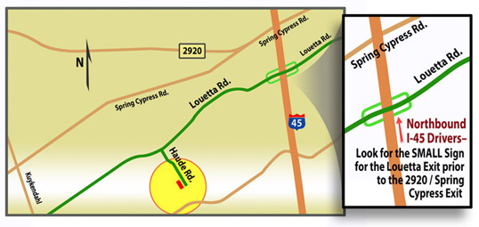

You can also visit us online at www.MMIA.co to find valuable information. We will soon have electronic payments set-up and will notify you when they become available.

As of AUGUST 1, 2022, Water and sewer related emergency and service calls should be directed to 281-651-1618. This is a 24 hour emergency response number. All after hour calls will be answered by an answering service and dispatched to on-call personnel.

MMIA is very pleased to be your new Water District Operator and is looking forward to a long and lasting relationship with the customers of the Timber Lane Utility District.

